**DeepMReye closed eye protocol (DeepMReyeClosed)**

The experiment will be run first in a 3T scanner, with combined backward video-projection (ProPixx HD resolution at 120Hz, max field of view of 20 dva, 120 cm from head) and eye-tracking (EyeLink monocular tracking at 1kHz, 13 points calibration before the scanner starts).

We will test 10 subjects in an experiment composed of 4 distinct parts (see below) in fixed order repeated 2 times (3 runs, ~6.5 min). Participants will be trained outside the scanner first to ensure data quality.

**Anatomical sequences**

* T1w : 0.8mm and 4:05 min (T1w_MPRAGE_vNav_0p8m),
* T2w : 0.8 mm and 2:35min (T2w_vNav_08mm)

**Fieldmap**

* Fieldmap_topup_AP 0:35 min
* Fieldmap_topup_PA, 0:35 min

**Scanning sequence**

* MB4, 2mm isotropic, 1.2 sec TR, whole head 60 slices, AP

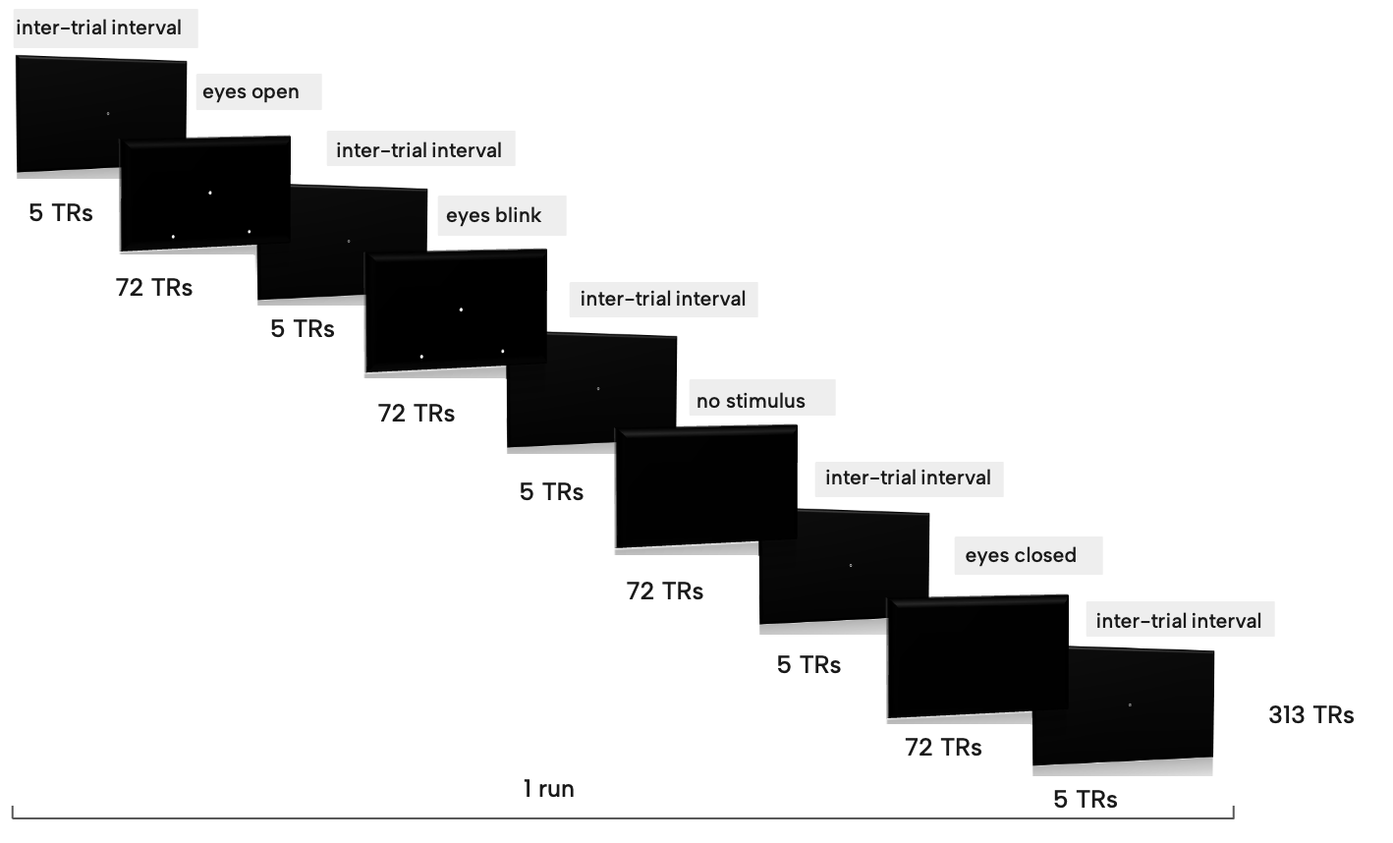

**Part 1: Eyes open**

Participant are instructed to fixate a bull’s eye displayed at position forming a triangle pointing in 4 cardinal locations with their tip at the screen center and their base at the side of a 18 dva side square. The presentation order of the displayed positions is fixed to make triangles pointing up, left, down and right. This generated 12 fixation trials of 3.6 seconds each (3 TR). A sequence of 3 sounds (440 Hz, 660 Hz and 880 Hz pure tone of 0.3 second each, separated by 0.9 second from the onset of the trial) rhythm the trial presentation mostly to train participants for the next parts.

- 24 trials per run

- End and start with inter-trial interval (ITI) 6.0 seconds (5 TRs) presented together with 5 sounds (300 Hz pure tone of 0.3 second each separated by 0.9 second from the onset of the trial).

- Duration of about ~ 1.5 min (including ITI)

**Part 2:** **Eyes blink**

Participant are instructed to fixate a bull’s eye (with the central part missing) displayed at position identical to those of the first part of the experiment, except that at instructed to blink from the onset of the second to the onset of the third tones.

- 24 trials per run

- End with inter-trial interval (ITI) of 6.0 seconds (5 TRs) presented together with 3 sounds as in part 1.

- Duration of about ~1.5 min (including ITI)

**Part 3: Eyes open without stimulus**

Participant are instructed to fixate at the position with their eyes open the whole time as presented in the first two parts, without the stimulus being presented anymore.

- 24 trials per run

- End with inter-trial interval (ITI) of 6.0 seconds (5 TRs) presented together with 3 sounds as in part 1.

- Duration of about ~1.5 min (including ITI)

**Part 4: Eyes close**

Participant are instructed while closing their eyes to fixate at the position as presented in the first two parts. They are guided by the three tones to keep the same pace as in previous parts.

- 24 trials per run

- End with inter-trial interval (ITI) of 6.0 seconds (5 TRs) presented together with 3 sounds as in part 1.

- Duration of about ~1.5 min (including ITI)